Declarative Programming

📌 Definition:
# Source: AI Source: Provided by: [Data Path: Persons Table -> ID Column: 1, Name_En Column: Motasem Essam] -> From: [Chatgpt (GPT‑5 Mini)] on [12/9/2025]
Declarative programming is a paradigm where you describe what you want to achieve, without specifying how to achieve it step-by-step.

🧠 Simple idea:
# Source: AI Source: Provided by: [Data Path: Persons Table -> ID Column: 1, Name_En Column: Motasem Essam] -> From: [Chatgpt (GPT‑5 Mini)] on [12/9/2025]
Declarative = “What to do” 🎯 (not how)

🔍 Key characteristics:
# Source: AI Source: Provided by: [Data Path: Persons Table -> ID Column: 1, Name_En Column: Motasem Essam] -> From: [Chatgpt (GPT‑5 Mini)] on [12/9/2025]
- 🎯 Focus on desired results
- ❌ No explicit control flow (no step-by-step logic)
- ⚙️ System decides how to execute
- 🧩 Often simpler and more readable

📌 Examples of Declarative Languages:

🗄️ SQL
# Source: AI Source: Provided by: [Data Path: Persons Table -> ID Column: 1, Name_En Column: Motasem Essam] -> From: [Chatgpt (GPT‑5 Mini)] on [12/9/2025]
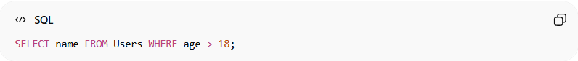
SELECT name FROM Users WHERE age > 18;
👉 You specify what data you want, not how to fetch it.

🏷️ HTML
# Source: AI Source: Provided by: [Data Path: Persons Table -> ID Column: 1, Name_En Column: Motasem Essam] -> From: [Chatgpt (GPT‑5 Mini)] on [12/9/2025]
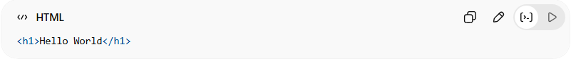
<h1>Hello World</h1>
👉 You describe what content is, not how to render it.

🎨 CSS
# Source: AI Source: Provided by: [Data Path: Persons Table -> ID Column: 1, Name_En Column: Motasem Essam] -> From: [Chatgpt (GPT‑5 Mini)] on [12/9/2025]
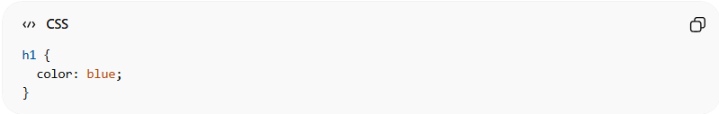
h1 {
color: blue;
}
👉 You describe what the style should be, not how to apply it.

🆚 Declarative vs Procedural
# Source: AI Source: Provided by: [Data Path: Persons Table -> ID Column: 1, Name_En Column: Motasem Essam] -> From: [Chatgpt (GPT‑5 Mini)] on [12/9/2025]
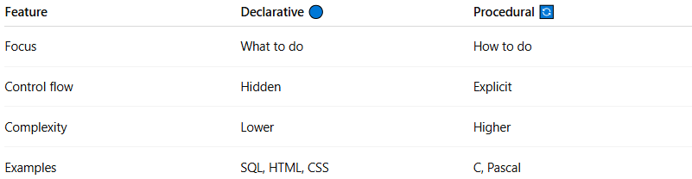
Feature | Declarative 🔵 | Procedural 🔄
Focus | What to do | How to do
Control flow | Hidden | Explicit
Complexity | Lower | Higher
Examples | SQL, HTML, CSS | C, Pascal

🧠 Types inside Declarative Programming:
# Source: AI Source: Provided by: [Data Path: Persons Table -> ID Column: 1, Name_En Column: Motasem Essam] -> From: [Chatgpt (GPT‑5 Mini)] on [12/9/2025]
- 🗄️ Query Languages (SQL)
- 🏷️ Markup Languages (HTML)
- 🎨 Style Sheet Languages (CSS)

🎯 Summary:
# Source: AI Source: Provided by: [Data Path: Persons Table -> ID Column: 1, Name_En Column: Motasem Essam] -> From: [Chatgpt (GPT‑5 Mini)] on [12/9/2025]
Declarative programming focuses on describing the desired outcome, letting the system decide how to achieve it.

